Name: Emmanuel Rendani

Surname: Mulungufhala

Student Number: ST10377210

Module: PROG6212PORPART3

**Here is the YouTube Link:** [**https://youtu.be/c14yrwxe0Rg**](https://youtu.be/c14yrwxe0Rg)

**Here is the github LINK:** [**https://github.com/EmmanuelRendaniMulungufhala/PROG6212-POEPART3final.git**](https://github.com/EmmanuelRendaniMulungufhala/PROG6212-POEPART3final.git)

**NB: Use Demo accounts to login into roles**

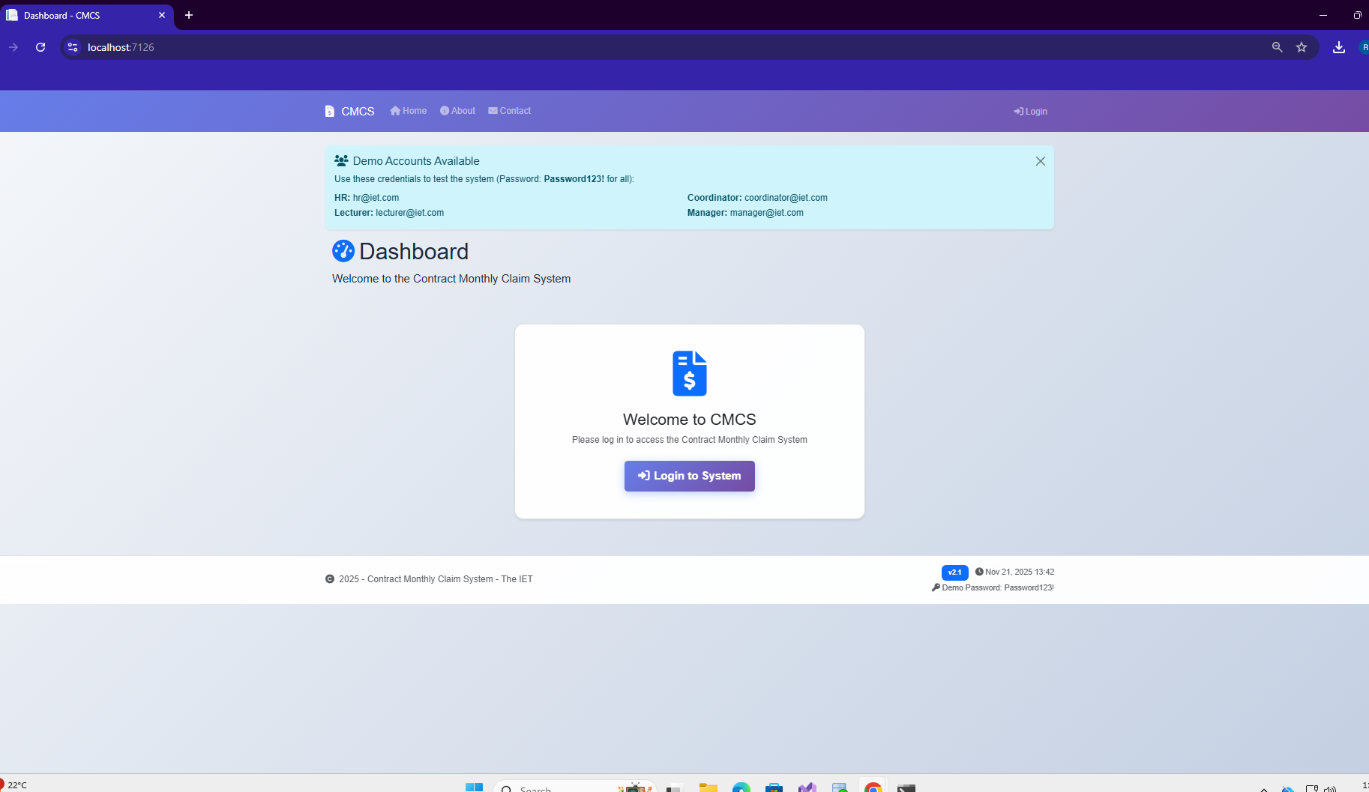

**Lecturer Dashboard**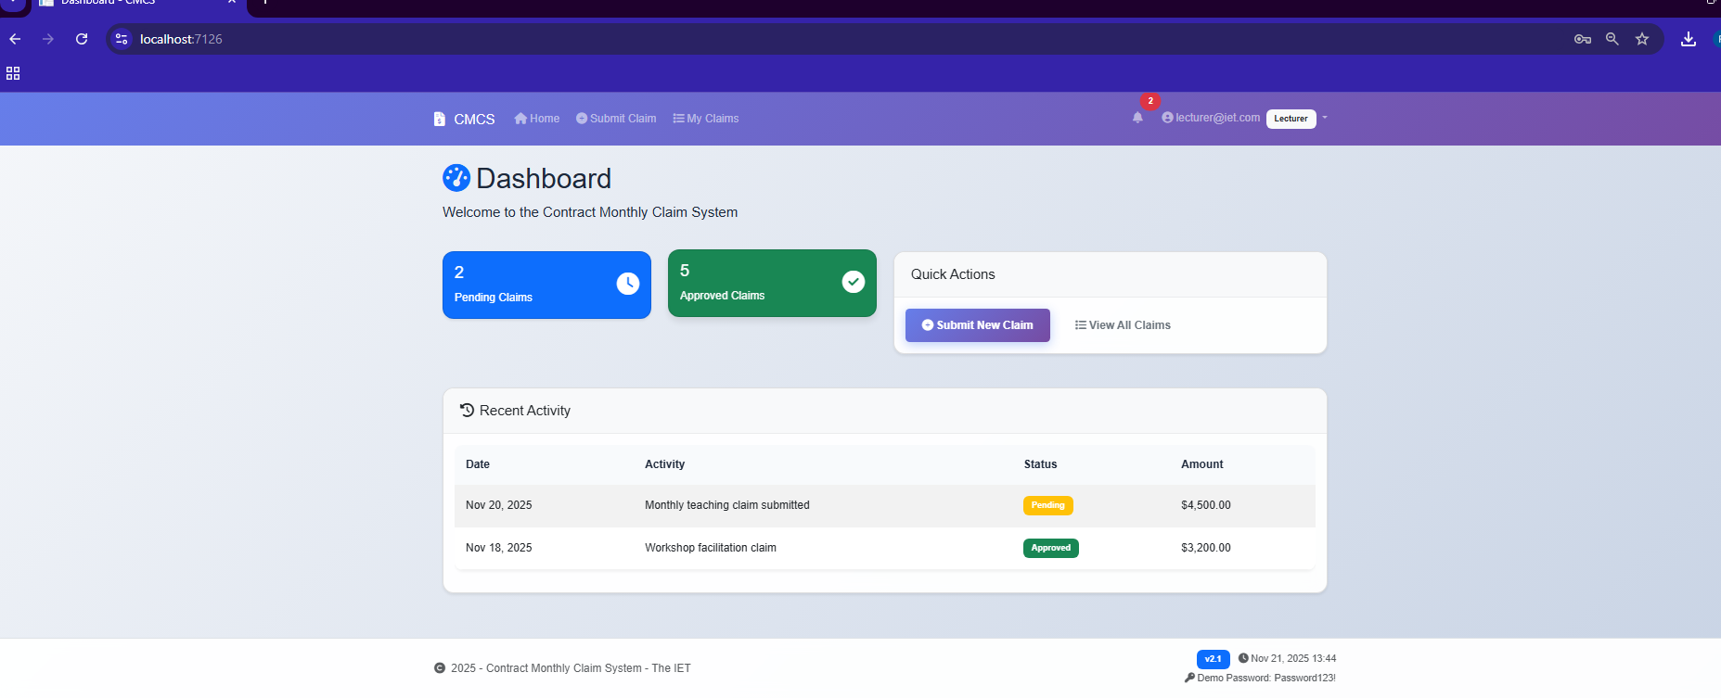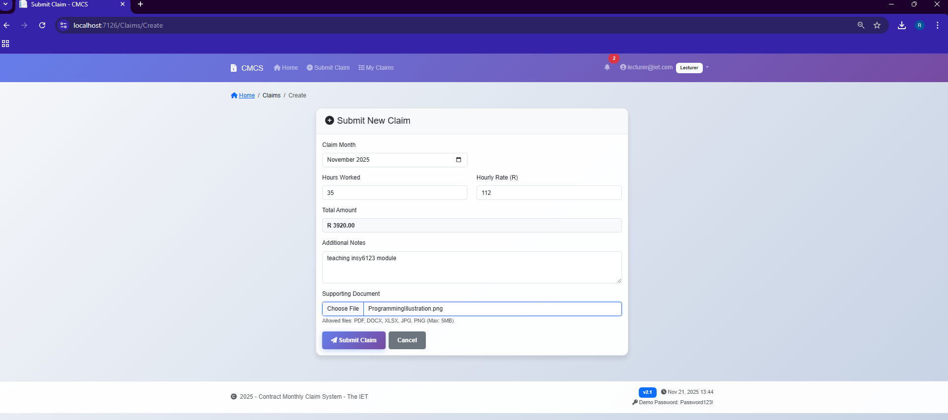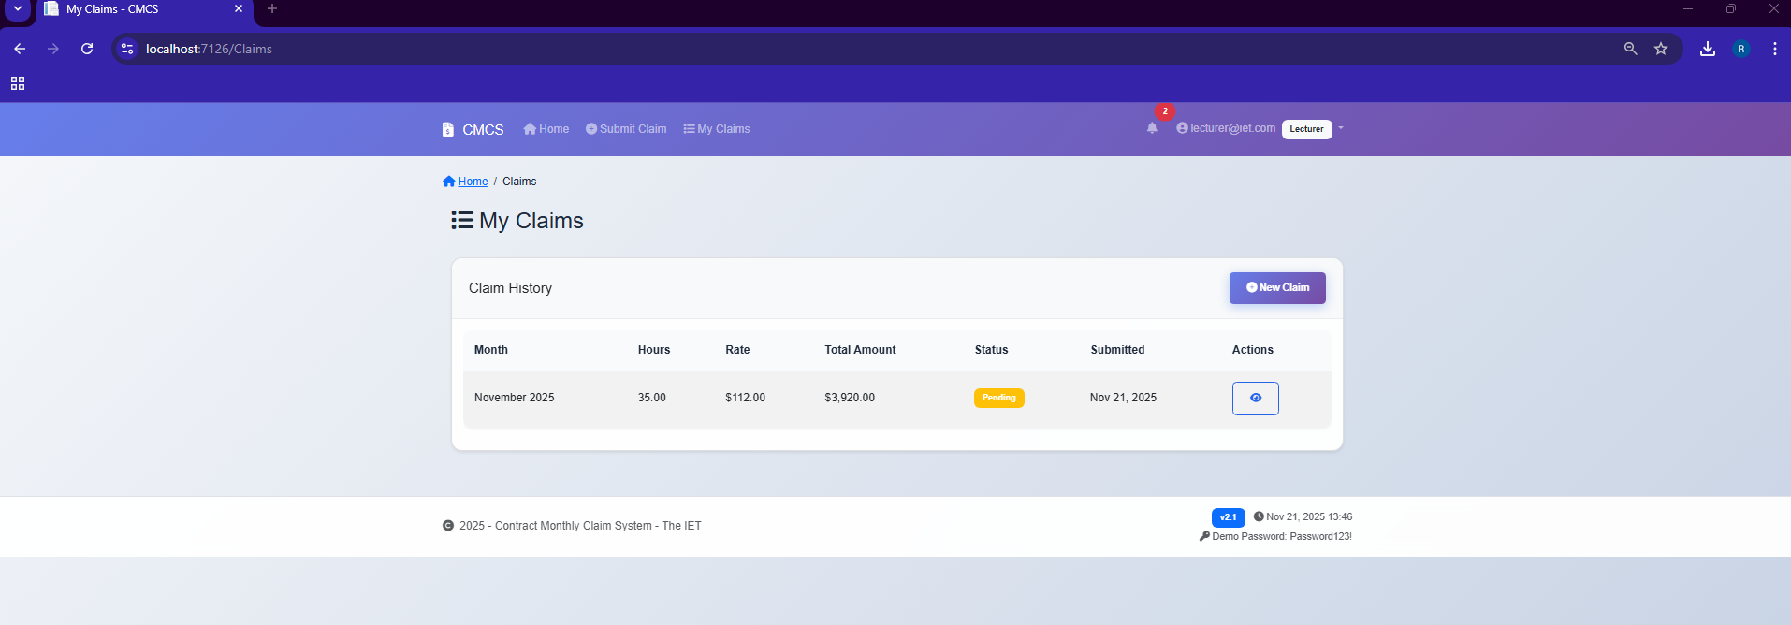

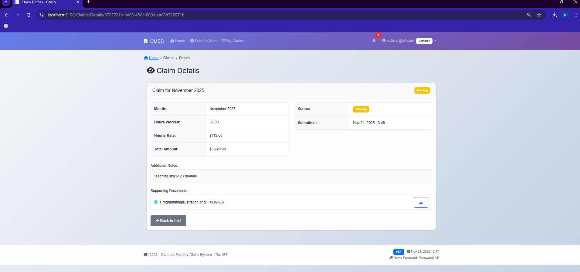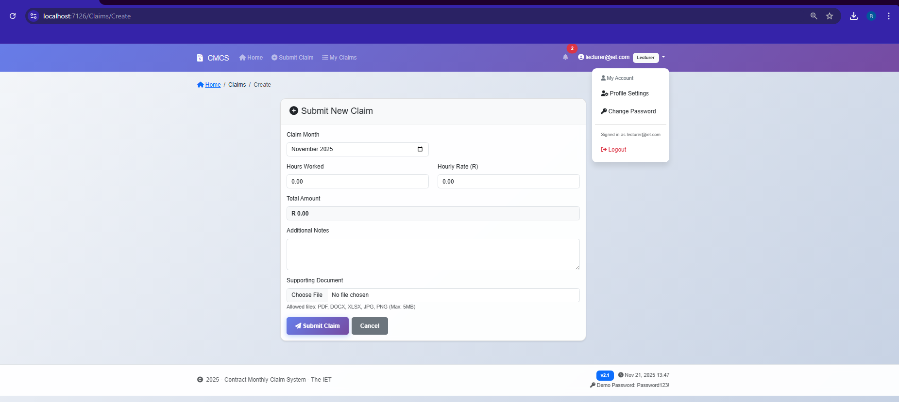

\.......................................................................................................................................**.coordinator Login**

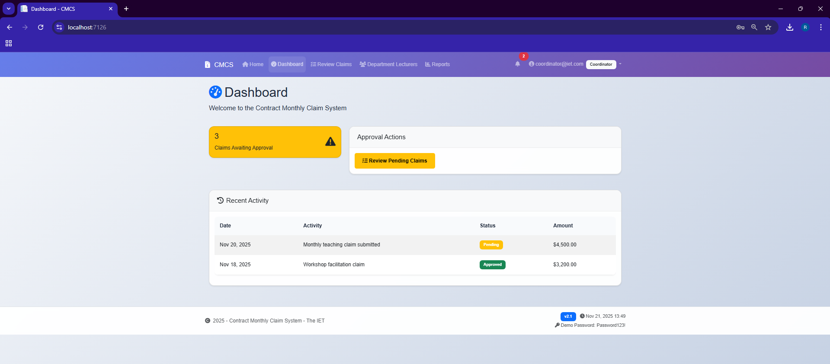

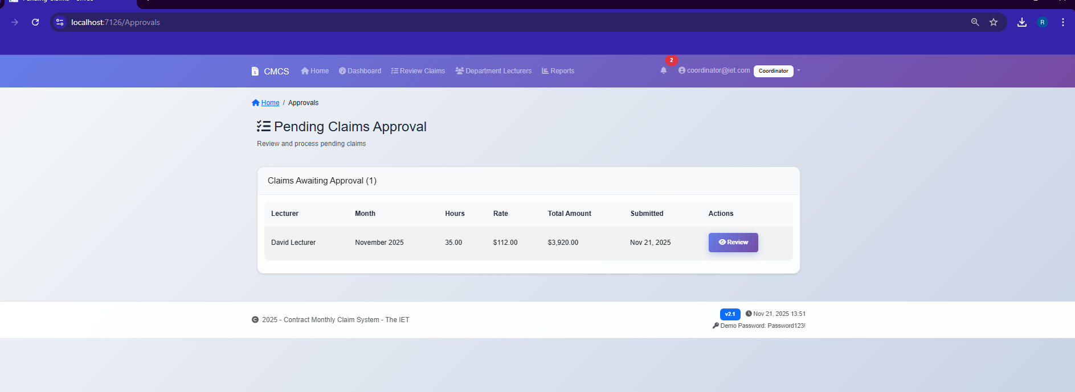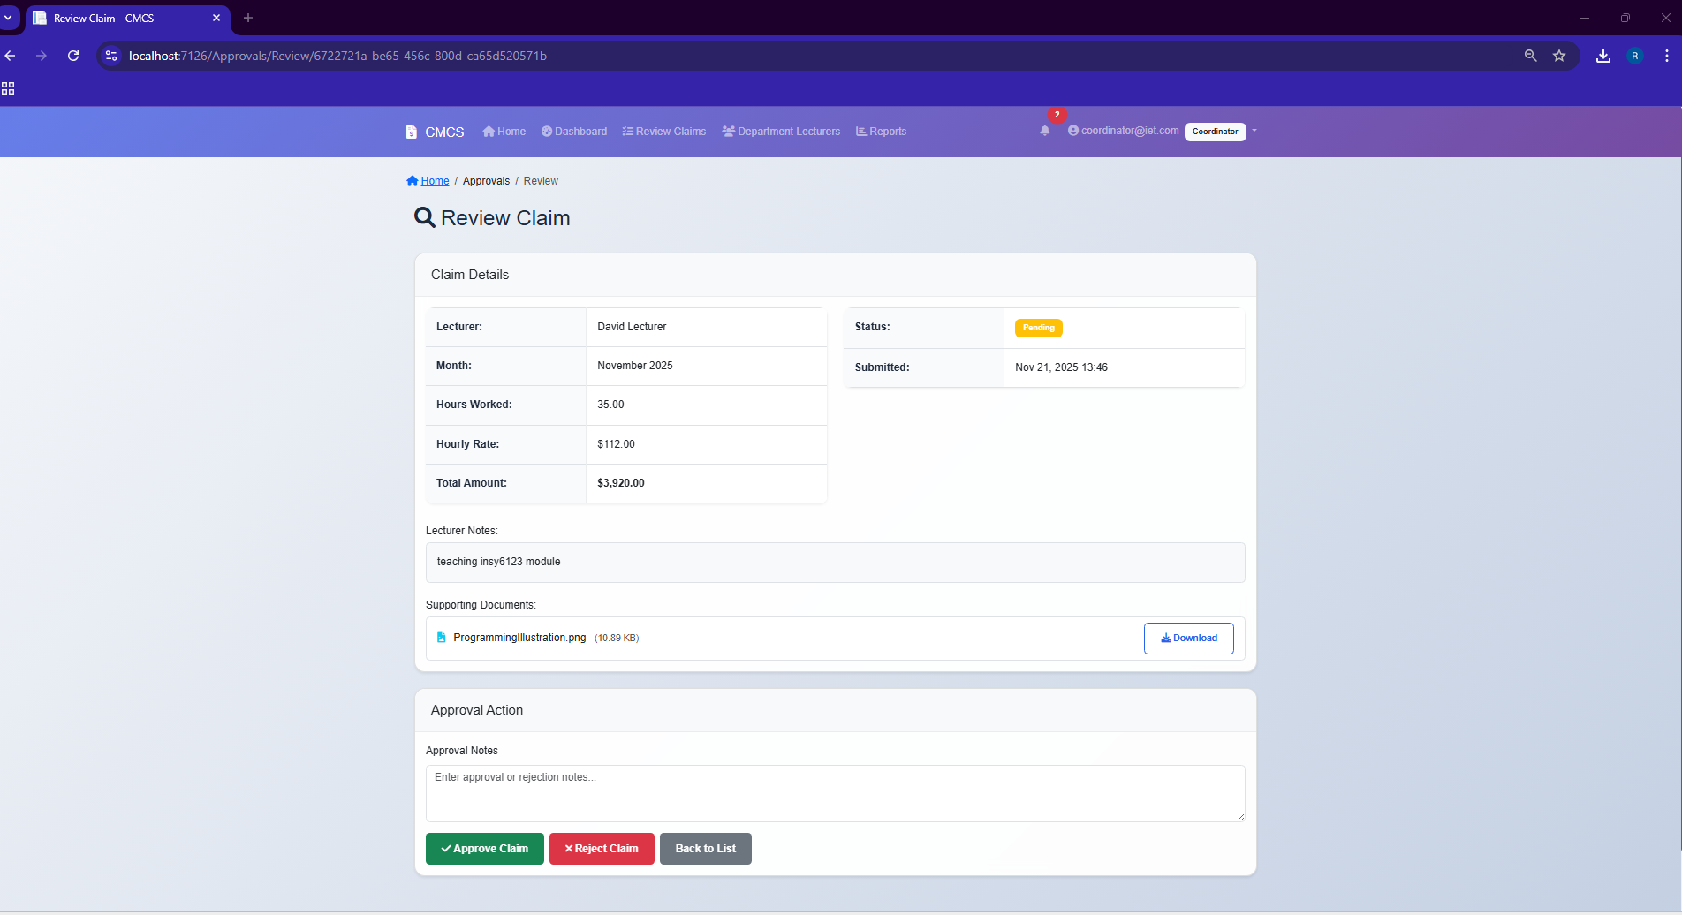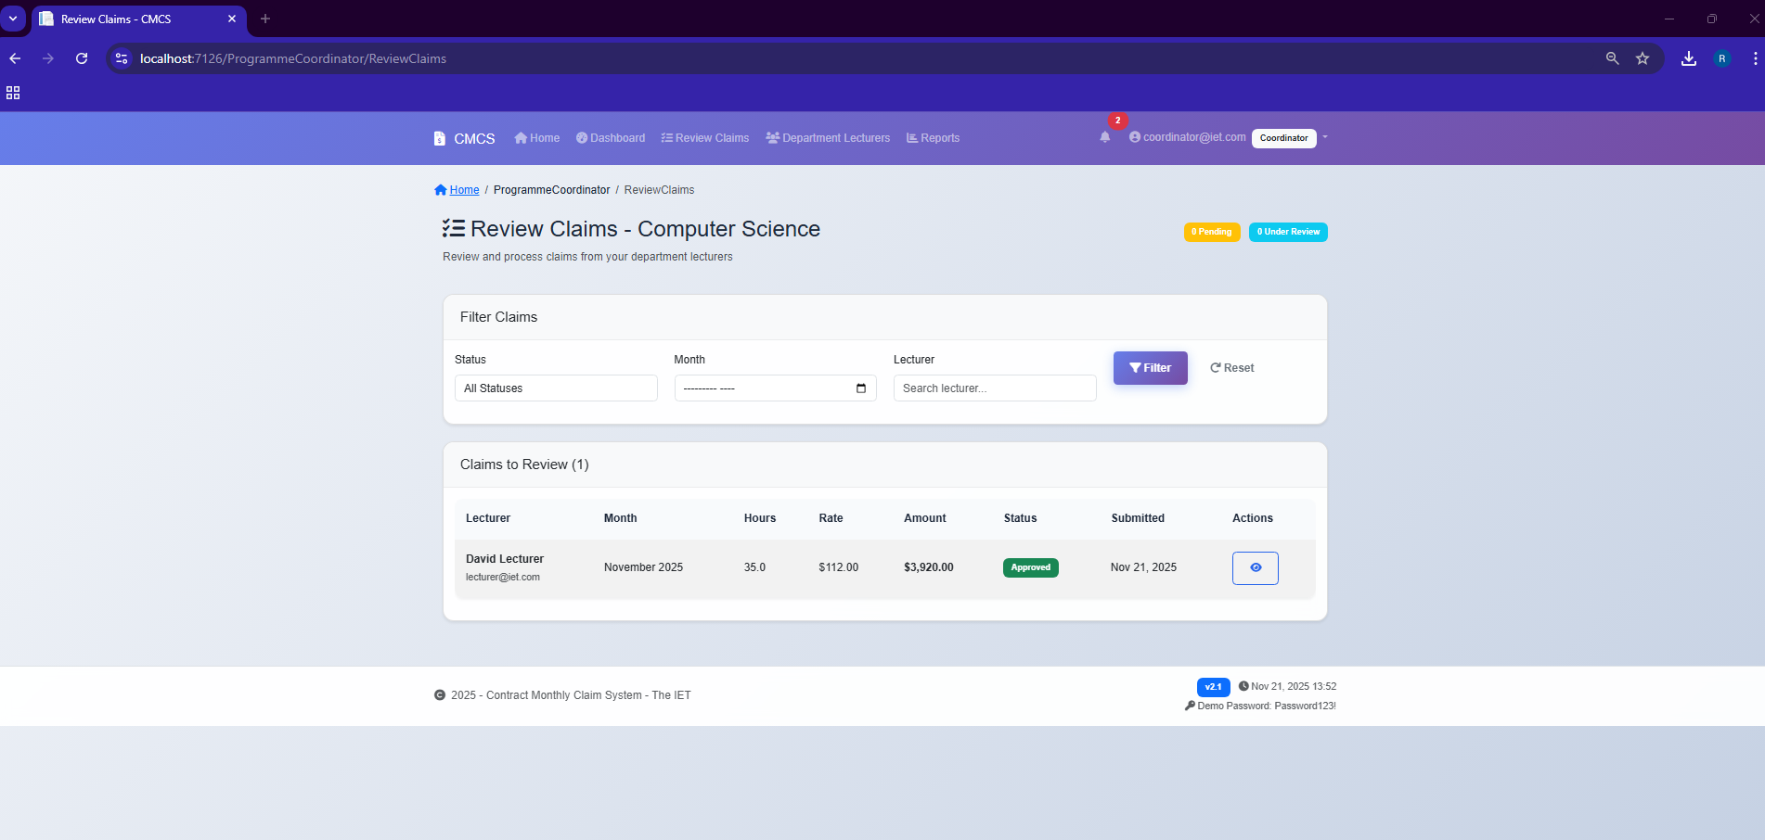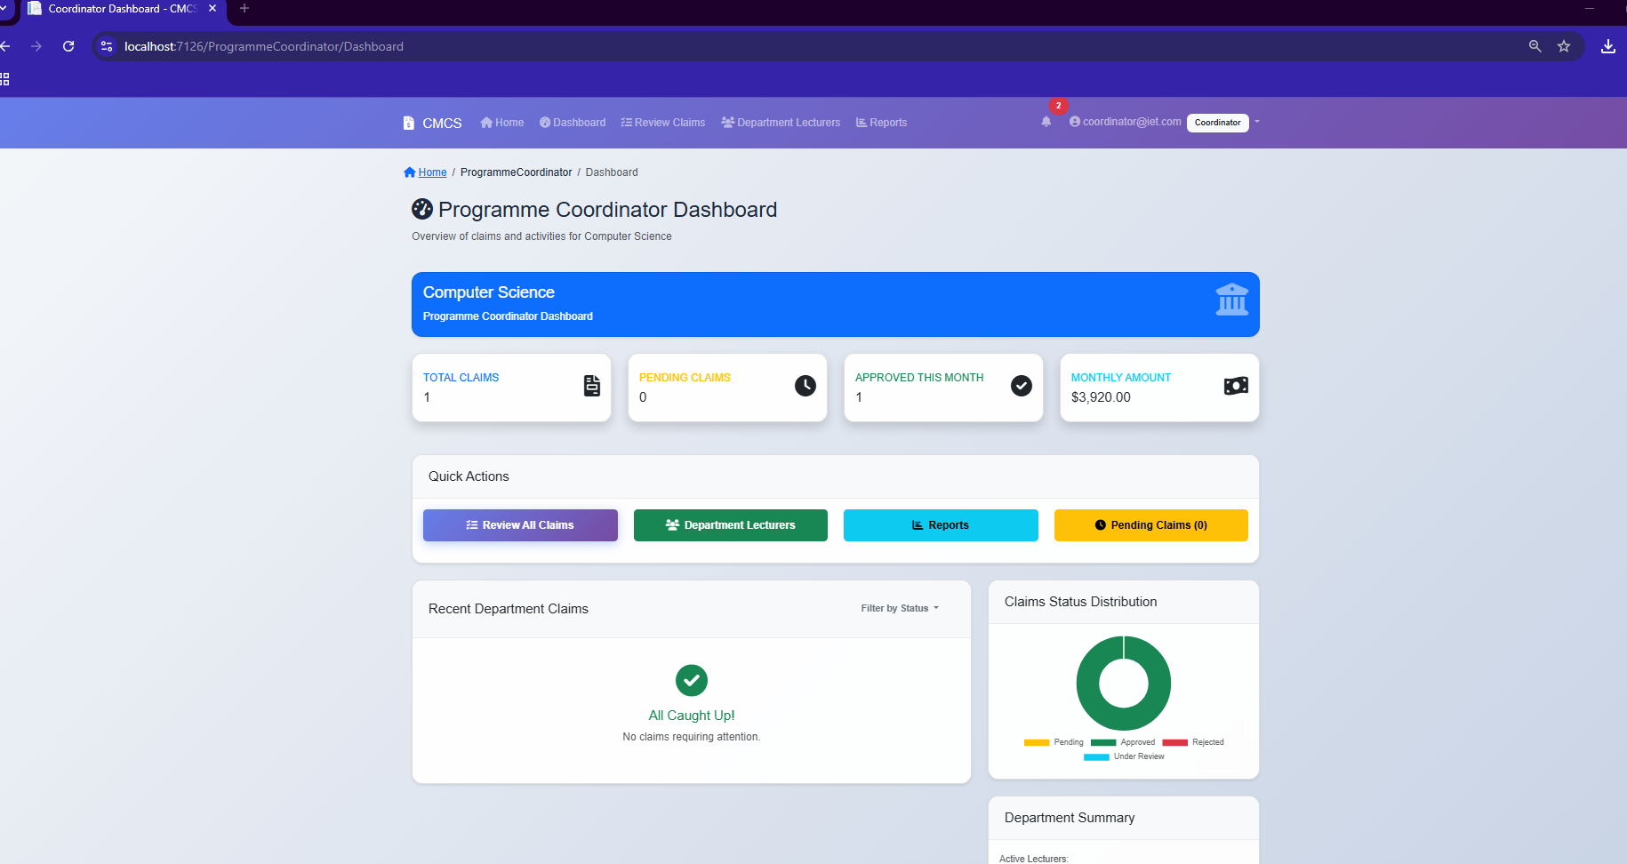

**MANGER DASHBOASRD**

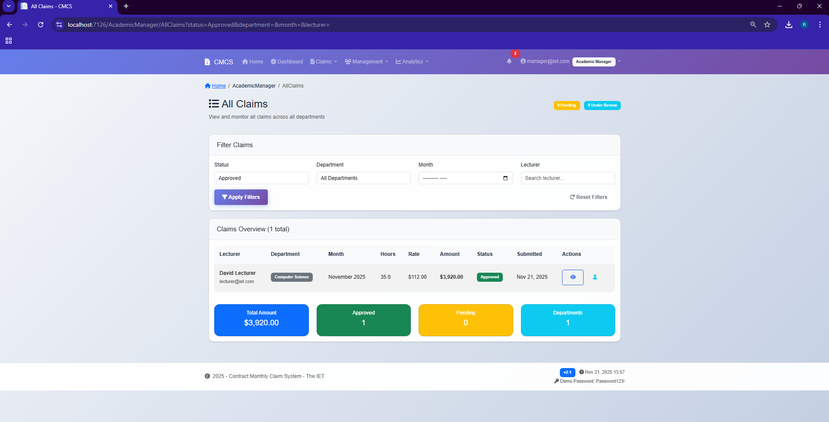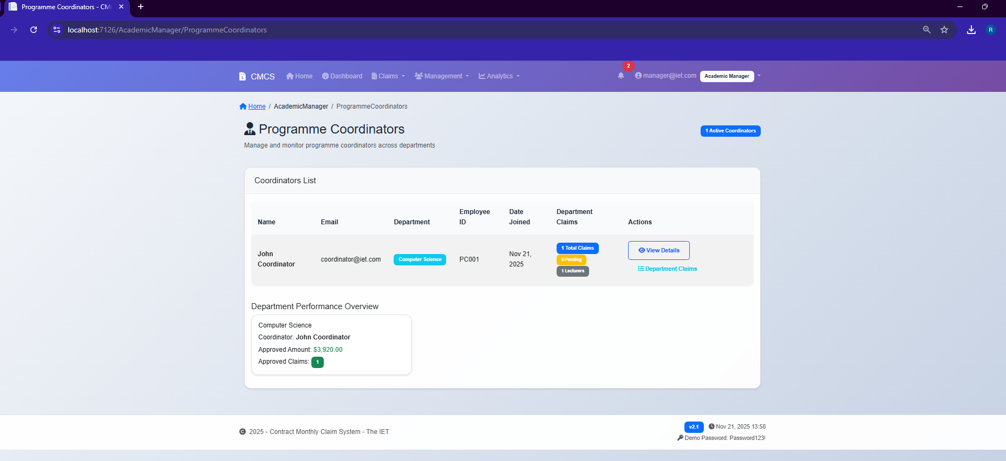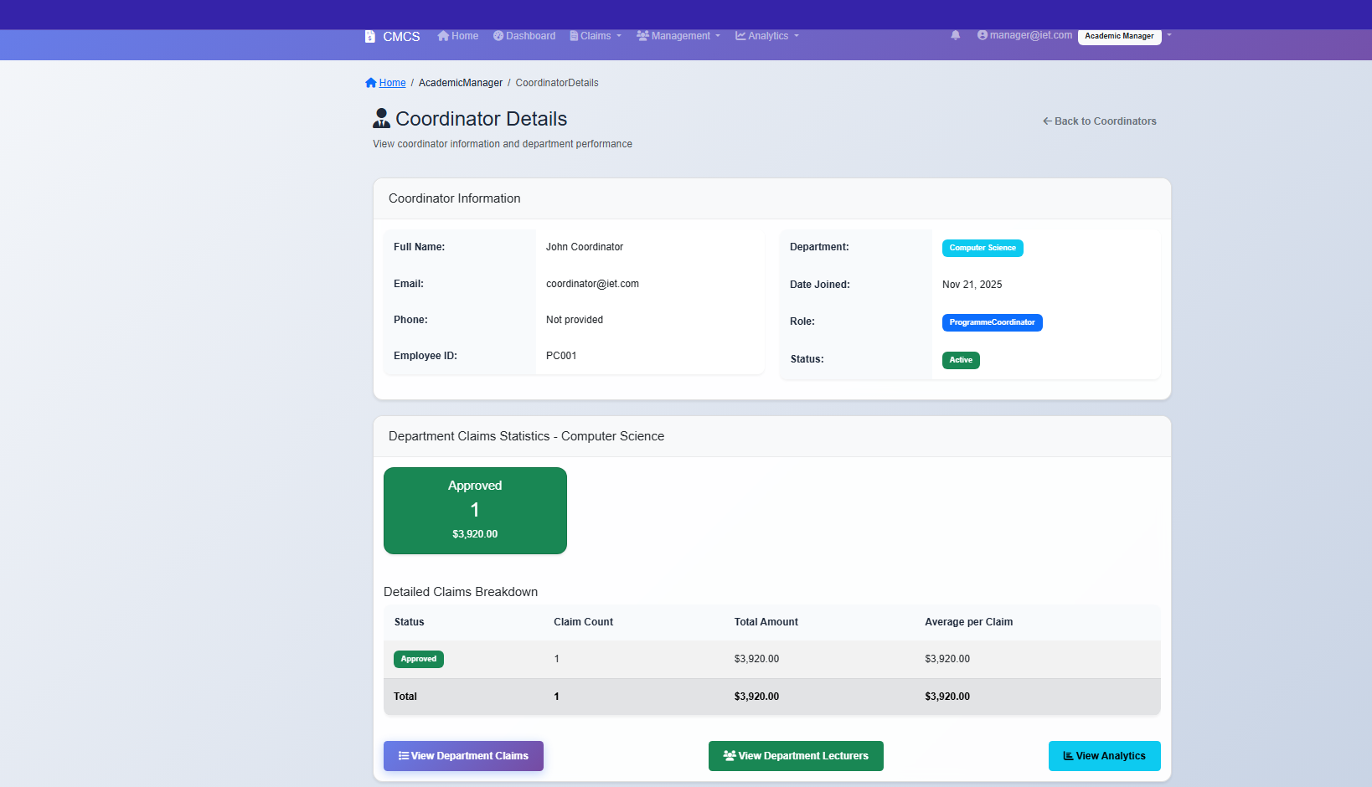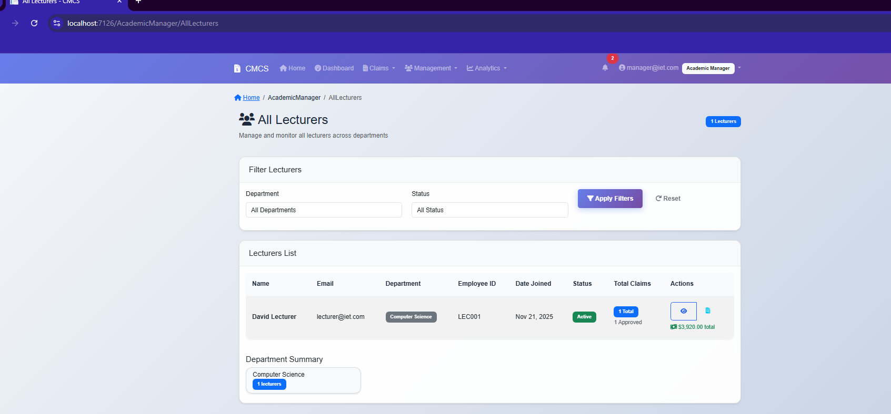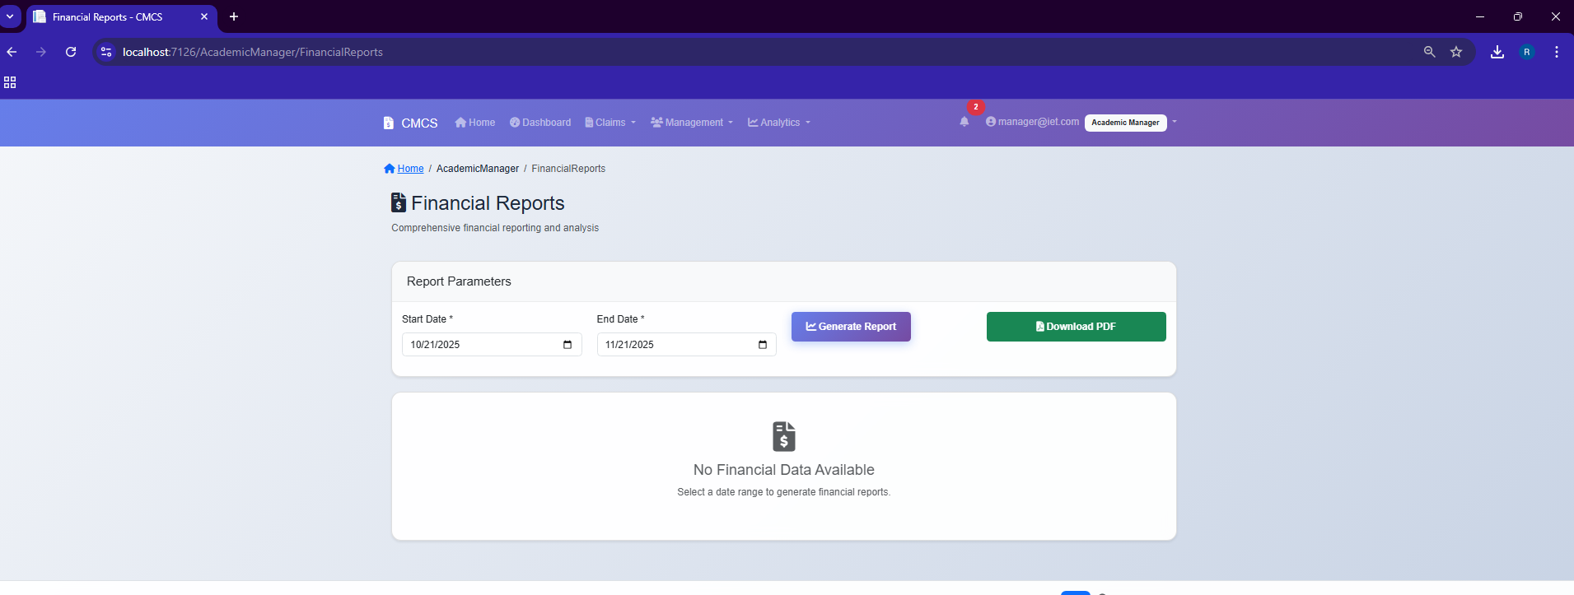

HR DASHBOARD

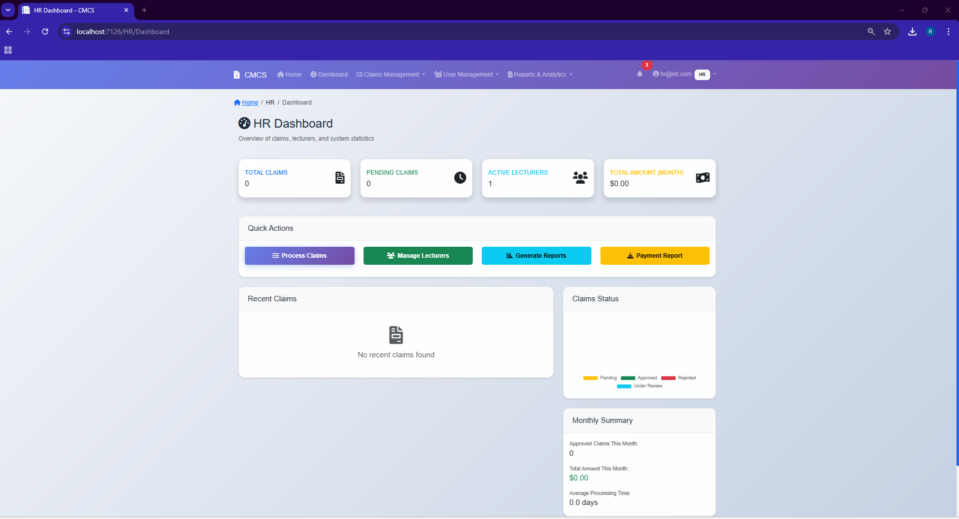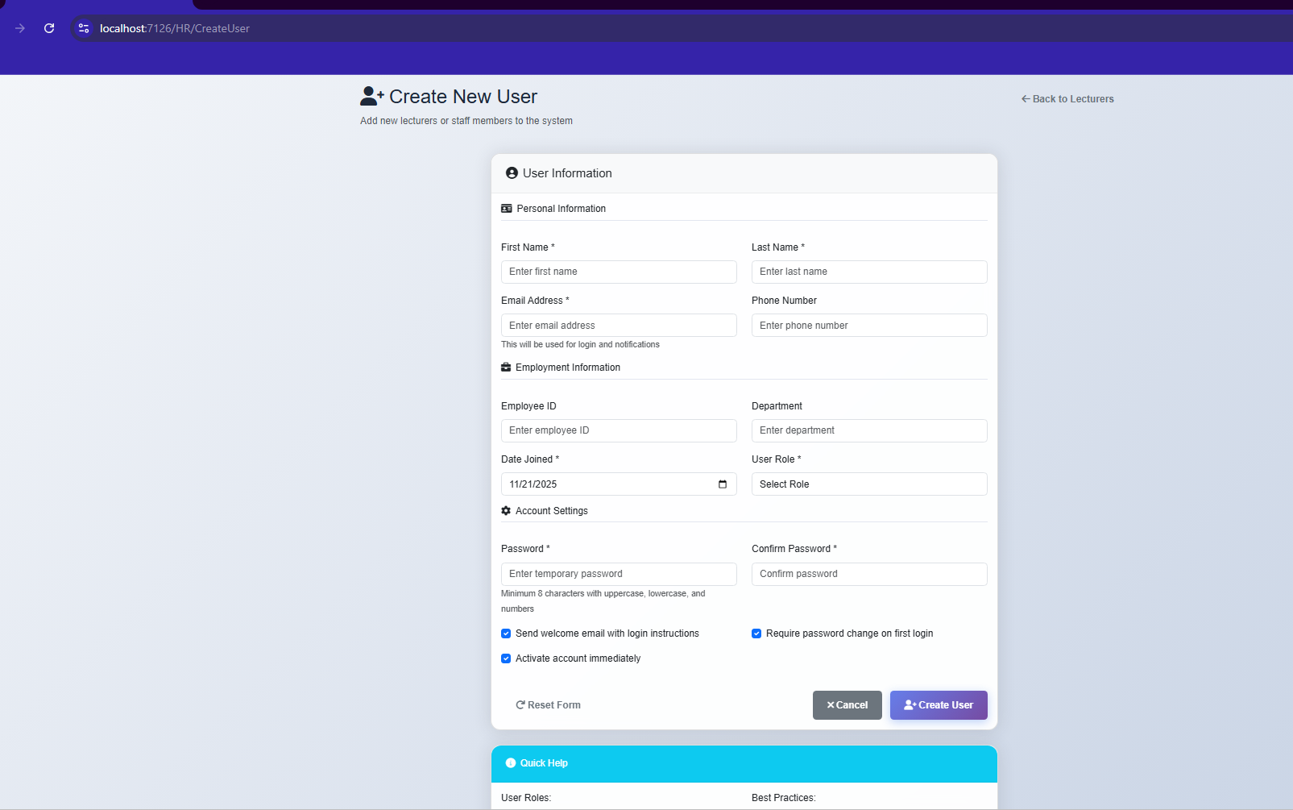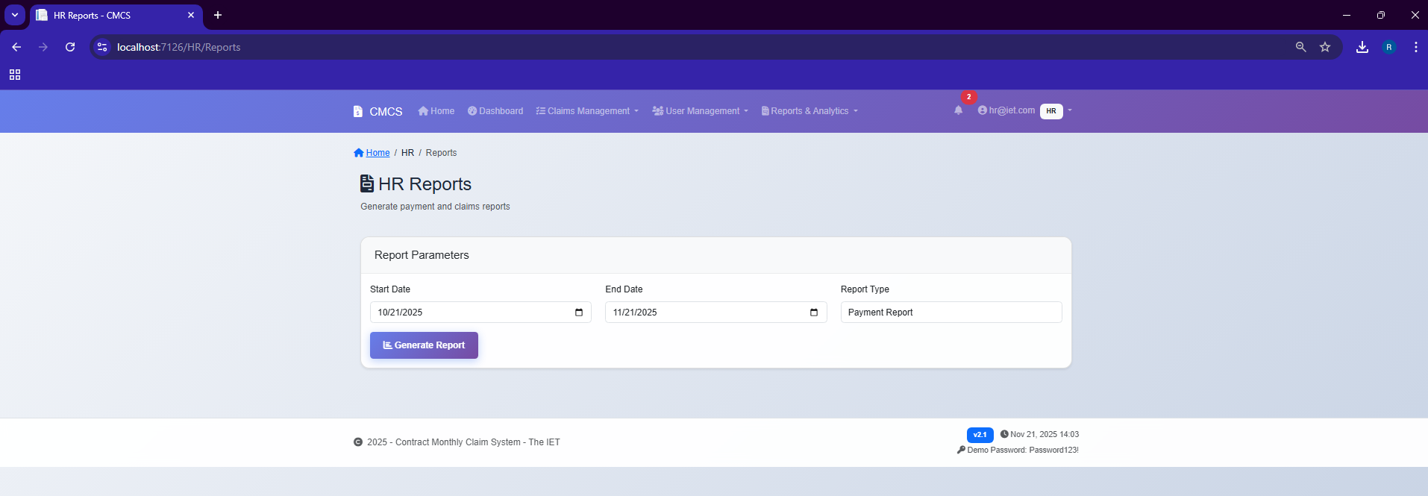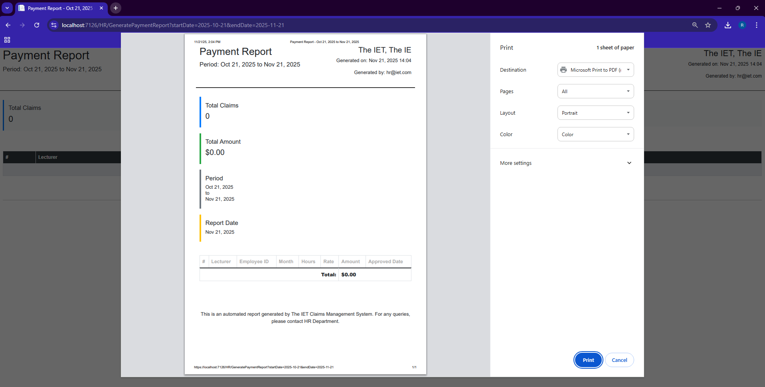

**SQL CODE**  
*Create Database*

IF NOT EXISTS (SELECT * FROM sys.databases WHERE name = 'ContractMonthlyClaimSystem')

BEGIN

CREATE DATABASE ContractMonthlyClaimSystem;

END

GO

USE ContractMonthlyClaimSystem;

GO

*-- ============================================================*

*-- DROP EXISTING TABLES (FOR CLEAN INSTALLATION)*

*-- ============================================================*

IF OBJECT_ID('dbo.Documents', 'U') IS NOT NULL DROP TABLE dbo.Documents;

IF OBJECT_ID('dbo.ClaimItems', 'U') IS NOT NULL DROP TABLE dbo.ClaimItems;

IF OBJECT_ID('dbo.Claims', 'U') IS NOT NULL DROP TABLE dbo.Claims;

IF OBJECT_ID('dbo.Users', 'U') IS NOT NULL DROP TABLE dbo.Users;

GO

*-- ============================================================*

*-- TABLE: Users*

*-- ============================================================*

CREATE TABLE Users (

UserId INT IDENTITY(1,1) PRIMARY KEY,

Username NVARCHAR(100) NOT NULL UNIQUE,

Email NVARCHAR(100) NOT NULL UNIQUE,

PasswordHash NVARCHAR(255) NOT NULL,

Role NVARCHAR(50) NOT NULL CHECK (Role IN ('Lecturer', 'Coordinator', 'Manager')),

FullName NVARCHAR(100) NOT NULL,

HourlyRate DECIMAL(18,2) NULL,

CreatedDate DATETIME NOT NULL DEFAULT GETDATE(),

IsActive BIT NOT NULL DEFAULT 1,

INDEX IX_Users_Email (Email),

INDEX IX_Users_Role (Role),

INDEX IX_Users_IsActive (IsActive)

);

GO

*-- ============================================================*

*-- TABLE: Claims*

*-- ============================================================*

CREATE TABLE Claims (

ClaimId INT IDENTITY(1,1) PRIMARY KEY,

LecturerId INT NOT NULL,

HoursWorked DECIMAL(18,2) NOT NULL CHECK (HoursWorked > 0),

HourlyRate DECIMAL(18,2) NOT NULL CHECK (HourlyRate > 0),

TotalAmount DECIMAL(18,2) NOT NULL,

Status NVARCHAR(50) NOT NULL DEFAULT 'Pending' CHECK (Status IN ('Pending', 'Verified', 'Approved', 'Rejected')),

SubmissionDate DATETIME NOT NULL DEFAULT GETDATE(),

ApprovalDate DATETIME NULL,

ApprovedBy INT NULL,

Comments NVARCHAR(500) NULL,

RejectionReason NVARCHAR(500) NULL,

Month INT NOT NULL CHECK (Month BETWEEN 1 AND 12),

Year INT NOT NULL CHECK (Year BETWEEN 2000 AND 2100),

CONSTRAINT FK_Claims_Lecturer FOREIGN KEY (LecturerId)

REFERENCES Users(UserId),

CONSTRAINT FK_Claims_Approver FOREIGN KEY (ApprovedBy)

REFERENCES Users(UserId),

INDEX IX_Claims_LecturerId (LecturerId),

INDEX IX_Claims_Status (Status),

INDEX IX_Claims_SubmissionDate (SubmissionDate),

INDEX IX_Claims_MonthYear (Month, Year)

);

GO

*-- ============================================================*

*-- TABLE: ClaimItems*

*-- ============================================================*

CREATE TABLE ClaimItems (

ClaimItemId INT IDENTITY(1,1) PRIMARY KEY,

ClaimId INT NOT NULL,

WorkDate DATE NOT NULL,

HoursWorked DECIMAL(18,2) NOT NULL CHECK (HoursWorked > 0),

Description NVARCHAR(500) NULL,

CONSTRAINT FK_ClaimItems_Claim FOREIGN KEY (ClaimId)

REFERENCES Claims(ClaimId) ON DELETE CASCADE,

INDEX IX_ClaimItems_ClaimId (ClaimId),

INDEX IX_ClaimItems_WorkDate (WorkDate)

);

GO

*-- ============================================================*

*-- TABLE: Documents*

*-- ============================================================*

CREATE TABLE Documents (

DocumentId INT IDENTITY(1,1) PRIMARY KEY,

ClaimId INT NOT NULL,

FileName NVARCHAR(255) NOT NULL,

FilePath NVARCHAR(500) NOT NULL,

FileType NVARCHAR(100) NULL,

FileSize BIGINT NOT NULL,

UploadDate DATETIME NOT NULL DEFAULT GETDATE(),

CONSTRAINT FK_Documents_Claim FOREIGN KEY (ClaimId)

REFERENCES Claims(ClaimId) ON DELETE CASCADE,

INDEX IX_Documents_ClaimId (ClaimId),

INDEX IX_Documents_UploadDate (UploadDate)

);

GO

*-- ============================================================*

*-- TRIGGER: Calculate Total Amount*

*-- ============================================================*

CREATE TRIGGER TR_Claims_CalculateTotalAmount

ON Claims

AFTER INSERT, UPDATE

AS

BEGIN

SET NOCOUNT ON;

UPDATE c

SET TotalAmount = c.HoursWorked * c.HourlyRate

FROM Claims c

INNER JOIN inserted i ON c.ClaimId = i.ClaimId

WHERE c.TotalAmount != (c.HoursWorked * c.HourlyRate);

END

GO

*-- ============================================================*

*-- STORED PROCEDURES*

*-- ============================================================*

*-- Get Claims by Status*

CREATE PROCEDURE sp_GetClaimsByStatus

@Status NVARCHAR(50)

AS

BEGIN

SELECT

c.ClaimId,

c.LecturerId,

u.FullName AS LecturerName,

u.Email AS LecturerEmail,

c.HoursWorked,

c.HourlyRate,

c.TotalAmount,

c.Status,

c.SubmissionDate,

c.ApprovalDate,

c.Comments,

c.RejectionReason,

c.Month,

c.Year

FROM Claims c

INNER JOIN Users u ON c.LecturerId = u.UserId

WHERE c.Status = @Status

ORDER BY c.SubmissionDate DESC;

END

GO

*-- Get Lecturer Dashboard Statistics*

CREATE PROCEDURE sp_GetLecturerDashboard

@LecturerId INT

AS

BEGIN

SELECT

COUNT(*) AS TotalClaims,

SUM(CASE WHEN Status = 'Pending' THEN 1 ELSE 0 END) AS PendingClaims,

SUM(CASE WHEN Status = 'Approved' THEN 1 ELSE 0 END) AS ApprovedClaims,

SUM(CASE WHEN Status = 'Rejected' THEN 1 ELSE 0 END) AS RejectedClaims,

SUM(CASE WHEN Status = 'Approved' THEN TotalAmount ELSE 0 END) AS TotalEarnings

FROM Claims

WHERE LecturerId = @LecturerId;

*-- Get recent claims*

SELECT TOP 5

ClaimId,

HoursWorked,

TotalAmount,

Status,

SubmissionDate,

Month,

Year

FROM Claims

WHERE LecturerId = @LecturerId

ORDER BY SubmissionDate DESC;

END

GO

*-- Get Manager Reports*

CREATE PROCEDURE sp_GetManagerReports

@StartDate DATETIME = NULL,

@EndDate DATETIME = NULL

AS

BEGIN

IF @StartDate IS NULL SET @StartDate = DATEADD(MONTH, -6, GETDATE());

IF @EndDate IS NULL SET @EndDate = GETDATE();

*-- Summary Statistics*

SELECT

COUNT(*) AS TotalClaims,

SUM(CASE WHEN Status = 'Approved' THEN 1 ELSE 0 END) AS ApprovedClaims,

SUM(CASE WHEN Status = 'Pending' OR Status = 'Verified' THEN 1 ELSE 0 END) AS PendingClaims,

SUM(CASE WHEN Status = 'Rejected' THEN 1 ELSE 0 END) AS RejectedClaims,

SUM(CASE WHEN Status = 'Approved' THEN TotalAmount ELSE 0 END) AS TotalPaid,

AVG(CASE WHEN Status = 'Approved' THEN TotalAmount END) AS AverageClaimAmount

FROM Claims

WHERE SubmissionDate BETWEEN @StartDate AND @EndDate;

*-- Claims by Lecturer*

SELECT

u.FullName AS LecturerName,

COUNT(*) AS ClaimCount,

SUM(c.TotalAmount) AS TotalAmount,

AVG(c.HoursWorked) AS AverageHours

FROM Claims c

INNER JOIN Users u ON c.LecturerId = u.UserId

WHERE c.SubmissionDate BETWEEN @StartDate AND @EndDate

AND c.Status = 'Approved'

GROUP BY u.FullName

ORDER BY TotalAmount DESC;

*-- Monthly Breakdown*

SELECT

YEAR(SubmissionDate) AS Year,

MONTH(SubmissionDate) AS Month,

COUNT(*) AS ClaimCount,

SUM(CASE WHEN Status = 'Approved' THEN TotalAmount ELSE 0 END) AS MonthlyTotal

FROM Claims

WHERE SubmissionDate BETWEEN @StartDate AND @EndDate

GROUP BY YEAR(SubmissionDate), MONTH(SubmissionDate)

ORDER BY Year DESC, Month DESC;

END

GO

*-- ============================================================*

*-- VIEWS*

*-- ============================================================*

*-- View: Pending Claims with Lecturer Details*

CREATE VIEW vw_PendingClaimsWithDetails

AS

SELECT

c.ClaimId,

c.LecturerId,

u.FullName AS LecturerName,

u.Email AS LecturerEmail,

u.HourlyRate AS LecturerRate,

c.HoursWorked,

c.TotalAmount,

c.Status,

c.SubmissionDate,

c.Month,

c.Year,

c.Comments,

(SELECT COUNT(*) FROM ClaimItems WHERE ClaimId = c.ClaimId) AS ItemCount,

(SELECT COUNT(*) FROM Documents WHERE ClaimId = c.ClaimId) AS DocumentCount

FROM Claims c

INNER JOIN Users u ON c.LecturerId = u.UserId

WHERE c.Status = 'Pending';

GO

*-- View: Claim History*

CREATE VIEW vw_ClaimHistory

AS

SELECT

c.ClaimId,

l.FullName AS LecturerName,

c.HoursWorked,

c.TotalAmount,

c.Status,

c.SubmissionDate,

c.ApprovalDate,

a.FullName AS ApproverName,

c.Month,

c.Year,

DATEDIFF(DAY, c.SubmissionDate,

ISNULL(c.ApprovalDate, GETDATE())) AS ProcessingDays

FROM Claims c

INNER JOIN Users l ON c.LecturerId = l.UserId

LEFT JOIN Users a ON c.ApprovedBy = a.UserId;

GO

*-- ============================================================*

*-- SEED DATA - Demo Users*

*-- ============================================================*

*-- Insert Demo Users (Password: 'password' - unhashed for demo)*

INSERT INTO Users (Username, Email, PasswordHash, Role, FullName, HourlyRate, CreatedDate, IsActive)

VALUES

('lecturer1', 'lecturer@cmcs.com', 'password', 'Lecturer', 'Dr. John Smith', 250.00, GETDATE(), 1),

('lecturer2', 'lecturer2@cmcs.com', 'password', 'Lecturer', 'Dr. Sarah Johnson', 275.00, GETDATE(), 1),

('lecturer3', 'lecturer3@cmcs.com', 'password', 'Lecturer', 'Prof. Michael Brown', 300.00, GETDATE(), 1),

('coordinator1', 'coordinator@cmcs.com', 'password', 'Coordinator', 'Jane Coordinator', NULL, GETDATE(), 1),

('coordinator2', 'coordinator2@cmcs.com', 'password', 'Coordinator', 'Mark Wilson', NULL, GETDATE(), 1),

('manager1', 'manager@cmcs.com', 'password', 'Manager', 'Bob Anderson', NULL, GETDATE(), 1);

GO

*-- ============================================================*

*-- SEED DATA - Sample Claims*

*-- ============================================================*

DECLARE @LecturerId INT = (SELECT UserId FROM Users WHERE Email = 'lecturer@cmcs.com');

DECLARE @CoordinatorId INT = (SELECT UserId FROM Users WHERE Email = 'coordinator@cmcs.com');

*-- Sample Claim 1 - Approved*

INSERT INTO Claims (LecturerId, HoursWorked, HourlyRate, TotalAmount, Status, SubmissionDate, ApprovalDate, ApprovedBy, Month, Year, Comments)

VALUES (@LecturerId, 40, 250.00, 10000.00, 'Approved', DATEADD(DAY, -15, GETDATE()), DATEADD(DAY, -10, GETDATE()), @CoordinatorId, 10, 2024, 'Regular monthly teaching hours');

DECLARE @ClaimId1 INT = SCOPE_IDENTITY();

*-- Sample Claim Items for Claim 1*

INSERT INTO ClaimItems (ClaimId, WorkDate, HoursWorked, Description)

VALUES

(@ClaimId1, DATEADD(DAY, -20, GETDATE()), 8, 'Introduction to Programming - Lecture'),

(@ClaimId1, DATEADD(DAY, -18, GETDATE()), 8, 'Data Structures - Lecture'),

(@ClaimId1, DATEADD(DAY, -16, GETDATE()), 8, 'Algorithms - Lecture'),

(@ClaimId1, DATEADD(DAY, -14, GETDATE()), 8, 'Database Systems - Lecture'),

(@ClaimId1, DATEADD(DAY, -12, GETDATE()), 8, 'Web Development - Lecture');

*-- Sample Claim 2 - Pending*

INSERT INTO Claims (LecturerId, HoursWorked, HourlyRate, TotalAmount, Status, SubmissionDate, Month, Year, Comments)

VALUES (@LecturerId, 45, 250.00, 11250.00, 'Pending', DATEADD(DAY, -2, GETDATE()), 11, 2024, 'November teaching hours including extra workshops');

DECLARE @ClaimId2 INT = SCOPE_IDENTITY();

INSERT INTO ClaimItems (ClaimId, WorkDate, HoursWorked, Description)

VALUES

(@ClaimId2, DATEADD(DAY, -5, GETDATE()), 9, 'Advanced Programming - Lecture and Workshop'),

(@ClaimId2, DATEADD(DAY, -4, GETDATE()), 9, 'Software Engineering - Lecture'),

(@ClaimId2, DATEADD(DAY, -3, GETDATE()), 9, 'Mobile Development - Lecture'),

(@ClaimId2, DATEADD(DAY, -2, GETDATE()), 9, 'Cloud Computing - Lecture'),

(@ClaimId2, DATEADD(DAY, -1, GETDATE()), 9, 'AI/ML Workshop - Extra Session');

*-- Sample Claim 3 - Verified*

DECLARE @LecturerId2 INT = (SELECT UserId FROM Users WHERE Email = 'lecturer2@cmcs.com');

INSERT INTO Claims (LecturerId, HoursWorked, HourlyRate, TotalAmount, Status, SubmissionDate, ApprovalDate, ApprovedBy, Month, Year)

VALUES (@LecturerId2, 38, 275.00, 10450.00, 'Verified', DATEADD(DAY, -5, GETDATE()), DATEADD(DAY, -2, GETDATE()), @CoordinatorId, 11, 2024);

*-- Sample Claim 4 - Rejected*

INSERT INTO Claims (LecturerId, HoursWorked, HourlyRate, TotalAmount, Status, SubmissionDate, ApprovalDate, ApprovedBy, Month, Year, RejectionReason)

VALUES (@LecturerId, 50, 250.00, 12500.00, 'Rejected', DATEADD(DAY, -30, GETDATE()), DATEADD(DAY, -25, GETDATE()), @CoordinatorId, 9, 2024, 'Hours exceed monthly maximum. Please submit supporting documentation.');

GO

*-- ============================================================*

*-- FUNCTIONS*

*-- ============================================================*

*-- Function: Calculate Total Claims by Lecturer*

CREATE FUNCTION fn_GetLecturerTotalClaims (@LecturerId INT)

RETURNS INT

AS

BEGIN

DECLARE @Total INT;

SELECT @Total = COUNT(*) FROM Claims WHERE LecturerId = @LecturerId;

RETURN ISNULL(@Total, 0);

END

GO

*-- Function: Calculate Total Earnings by Lecturer*

CREATE FUNCTION fn_GetLecturerTotalEarnings (@LecturerId INT)

RETURNS DECIMAL(18,2)

AS

BEGIN

DECLARE @Total DECIMAL(18,2);

SELECT @Total = SUM(TotalAmount)

FROM Claims

WHERE LecturerId = @LecturerId AND Status = 'Approved';

RETURN ISNULL(@Total, 0);

END

GO

*-- ============================================================*

*-- INDEXES FOR PERFORMANCE*

*-- ============================================================*

*-- Composite indexes for common queries*

CREATE INDEX IX_Claims_Status_SubmissionDate ON Claims(Status, SubmissionDate DESC);

CREATE INDEX IX_Claims_LecturerId_Status ON Claims(LecturerId, Status);

CREATE INDEX IX_ClaimItems_ClaimId_WorkDate ON ClaimItems(ClaimId, WorkDate);

GO

*-- ============================================================*

*-- AUDIT TRIGGER - Track Claim Status Changes*

*-- ============================================================*

*-- Create Audit Table*

CREATE TABLE ClaimAuditLog (

AuditId INT IDENTITY(1,1) PRIMARY KEY,

ClaimId INT NOT NULL,

OldStatus NVARCHAR(50),

NewStatus NVARCHAR(50),

ChangedBy INT NULL,

ChangeDate DATETIME NOT NULL DEFAULT GETDATE(),

Comments NVARCHAR(500)

);

GO

*-- Create Audit Trigger*

CREATE TRIGGER TR_Claims_AuditStatusChange

ON Claims

AFTER UPDATE

AS

BEGIN

SET NOCOUNT ON;

INSERT INTO ClaimAuditLog (ClaimId, OldStatus, NewStatus, ChangedBy, ChangeDate, Comments)

SELECT

i.ClaimId,

d.Status AS OldStatus,

i.Status AS NewStatus,

i.ApprovedBy,

GETDATE(),

CASE

WHEN i.Status = 'Rejected' THEN i.RejectionReason

ELSE i.Comments

END

FROM inserted i

INNER JOIN deleted d ON i.ClaimId = d.ClaimId

WHERE i.Status <> d.Status;

END

GO

*-- ============================================================*

*-- UTILITY QUERIES FOR TESTING*

*-- ============================================================*

*-- Query 1: View all users by role*

SELECT * FROM Users ORDER BY Role, FullName;

*-- Query 2: View all claims with details*

SELECT

c.ClaimId,

u.FullName AS Lecturer,

c.HoursWorked,

c.HourlyRate,

c.TotalAmount,

c.Status,

c.SubmissionDate,

c.Month,

c.Year

FROM Claims c

INNER JOIN Users u ON c.LecturerId = u.UserId

ORDER BY c.SubmissionDate DESC;

*-- Query 3: Get pending claims count*

SELECT Status, COUNT(*) AS Count

FROM Claims

GROUP BY Status;

*-- Query 4: Get lecturer earnings*

SELECT

u.FullName,

COUNT(*) AS TotalClaims,

SUM(CASE WHEN c.Status = 'Approved' THEN c.TotalAmount ELSE 0 END) AS TotalEarnings

FROM Users u

LEFT JOIN Claims c ON u.UserId = c.LecturerId

WHERE u.Role = 'Lecturer'

GROUP BY u.FullName;

GO

*-- ============================================================*

*-- DATABASE BACKUP RECOMMENDATION*

*-- ============================================================*

*-- Recommended backup script (run as separate job)*

*/\**

BACKUP DATABASE ContractMonthlyClaimSystem

TO DISK = 'C:\Backups\CMCS_Full.bak'

WITH FORMAT, INIT, COMPRESSION,

NAME = 'Full Backup of Contract Monthly Claim System';

*\*/*

*-- ============================================================*

*-- SCRIPT COMPLETION*

*-- ============================================================*

PRINT '============================================================';

PRINT 'Contract Monthly Claim System Database Setup Complete!';

PRINT '============================================================';

PRINT 'Database: ContractMonthlyClaimSystem';

PRINT 'Tables Created: Users, Claims, ClaimItems, Documents';

PRINT 'Stored Procedures: 3';

PRINT 'Views: 2';

PRINT 'Triggers: 2';

PRINT 'Functions: 2';

PRINT 'Demo Users: 6 (3 Lecturers, 2 Coordinators, 1 Manager)';

PRINT 'Sample Claims: 4';

PRINT '============================================================';

PRINT 'Demo Login Credentials:';

PRINT 'Lecturer: lecturer@cmcs.com / password';

PRINT 'Coordinator: coordinator@cmcs.com / password';

PRINT 'Manager: manager@cmcs.com / password';

PRINT '============================================================';

GO

**Lecture Feedback**

**What l improved for part 3**

All created claims now show

from lecturer

so when you press pending claims it will show all pending claims

Coordinator can see created claims

so as Manger And HR

**Reference list  
W3Schools. n.d. *SQL Tutorial*. Available at:** [**https://www.w3schools.com/sql/default.asp**](https://www.w3schools.com/sql/default.asp)**. (Accessed 19 November 2025).**

**W3Schools. n.d. *CSS Backgrounds*. Available at:** [**https://www.w3schools.com/css/css_background.asp**](https://www.w3schools.com/css/css_background.asp)**. (Accessed 19 November 2025).**

**W3Schools. n.d. *C# Tutorial*. Available at:** [**https://www.w3schools.com/cs/index.php**](https://www.w3schools.com/cs/index.php)**. (Accessed 19 November 2025).**